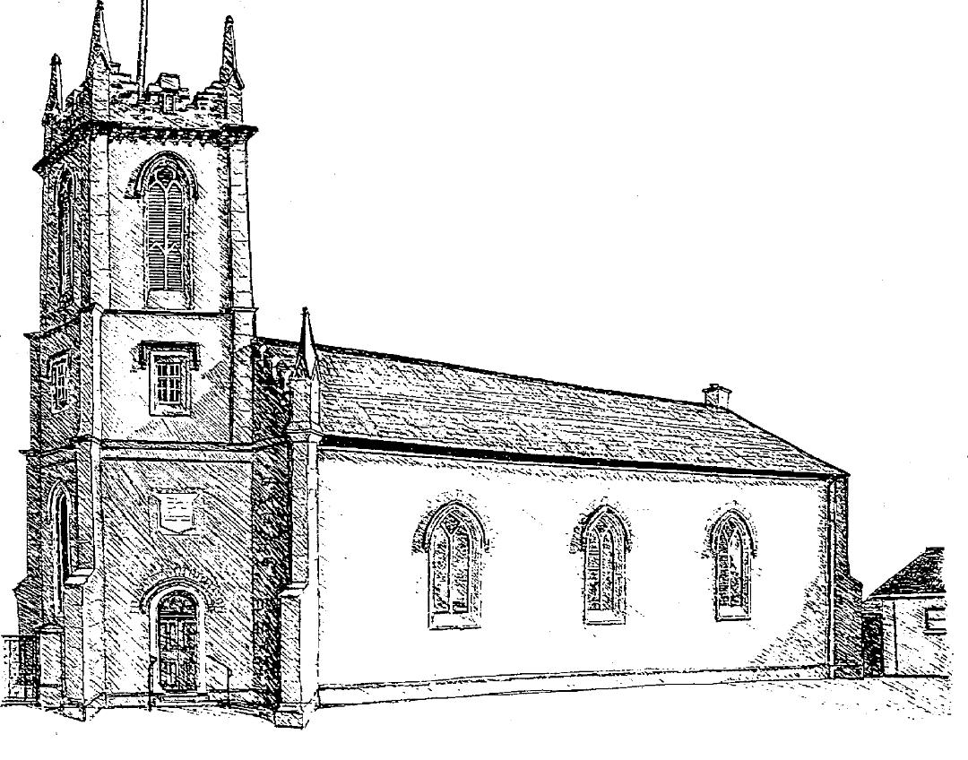

**St. Andrew’s Church, Parish of Killyman**

Your privacy is important to us, and we want to communicate with church members in a way which has their consent, and which is in line with European Law on Data Protection. As a result of a change in Data Protection regulation, we now need your consent as to how we contact you. Please fill in the contact details you want us to use to communicate with you.

***We require every parishioner to fill out and sign a form***

**For those under 13 years of age, parent/guardian required to sign the form below.**

|  |  |
| --- | --- |
| **Name** |  |
| **Address** |  |
| **Email Address** |  |
| **Home Phone Number** |  |
| **Mobile Phone Number** |  |
| **If the information provided is for someone aged under 13 years, please tick here** ☐ | |

By signing this form you are confirming that you are consenting to Killyman Parish holding and processing your personal data for the following purposes *(please tick the boxes where you grant consent)*:-

I consent to the church contacting me by ☐post ☐phone ☐email in order to:

☐ Keep me informed about news, events, activities and services in the Parish

☐ Share my contact details with the Diocese of Armagh so they can keep me informed about news, events, activities and services that will be occurring in the diocese.

☐ I consent to Killyman Parish taking photographs of me at Parish events and sharing / using these photographs on our website, Facebook page, diocesan publications and other places as appropriate.

☐ I consent to Authorized Parish Representatives visiting me at home, hospital, etc for the purpose of Pastoral Care.

*Signed: **______________________________** Dated: **__________________**

*parental / guardian signature required for those under 13 years of age

You can grant consent to all the purposes; one of the purposes or none of the purposes. Where you do not grant consent we will not be able to use your personal data; (so for example we may not be able to let you know about forthcoming services and events); except in certain limited situations, such as where required to do so by law or to protect members of the public from serious harm. You can find out more about how we use your data from our “Data Privacy Notice” which is available from the Rector.

You can withdraw or change your consent at any time by contacting Heather Stewart at [killymancoi@outlook.com](mailto:killymancoi@outlook.com). Please note that all processing of your personal data will cease once you have withdrawn consent, other than where this is required by law, but this will not affect any personal data that has already been processed prior to this point.